**Update TC-ENV Server**

**Overview**

1. Update Code (all servers)
2. Update Database (only from one server)
3. Restart Server (all servers)
4. Troubleshooting

**1. Update Code**

1. RDP in



1. Run Windows Update and install any updates

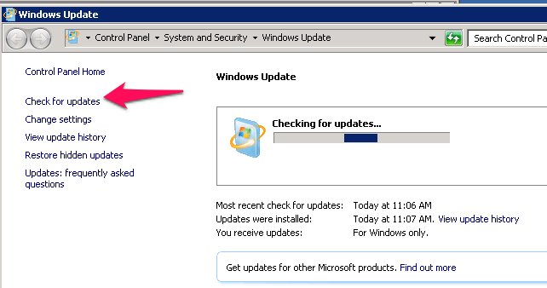

1. Run “As Administrator” SourceTree
2. Enter password at prompt

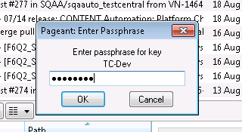

Password:



1. Should see something like this (with “master” branch in bold)

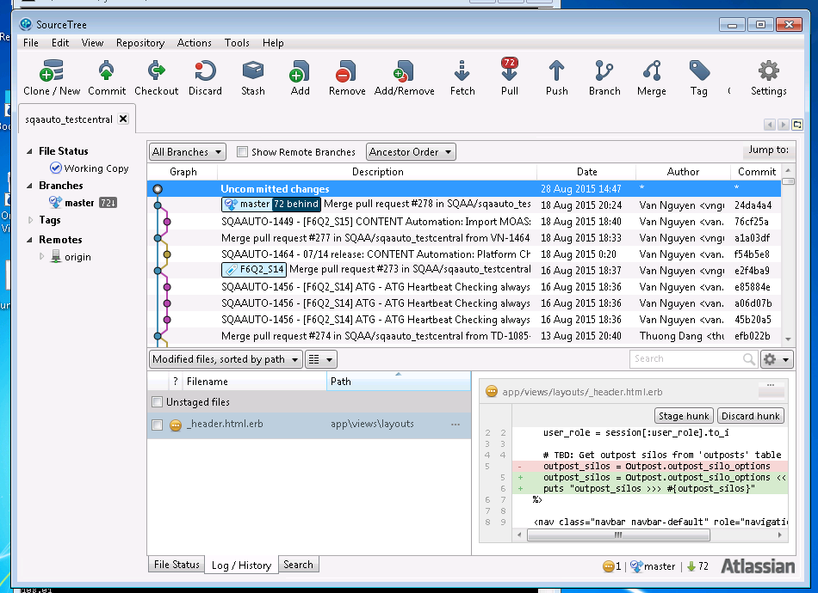

1. Click Fetch, click OK

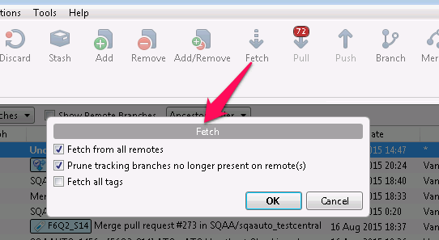

1. Click Pull, click OK

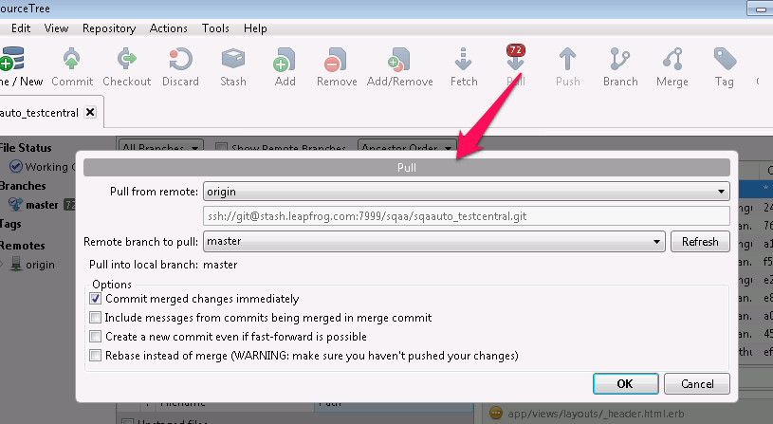

1. Resolve any issues

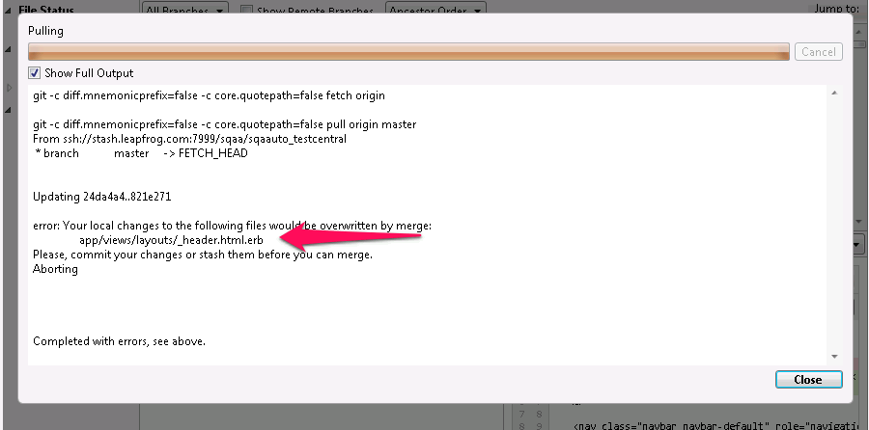

1. Expect “master” to be updated

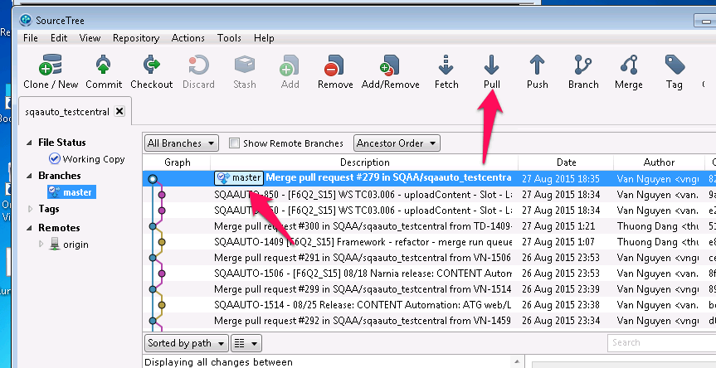

1. Open “As Administrator” Command prompt and do Bundle

cd \dev\sqaauto_testcentral

bundle

**2. Update Database**

1. Open “As Administrator” Command prompt and save a snapshot of the database

cd \dev\sqaauto_testcentral

rake db:snapshot  
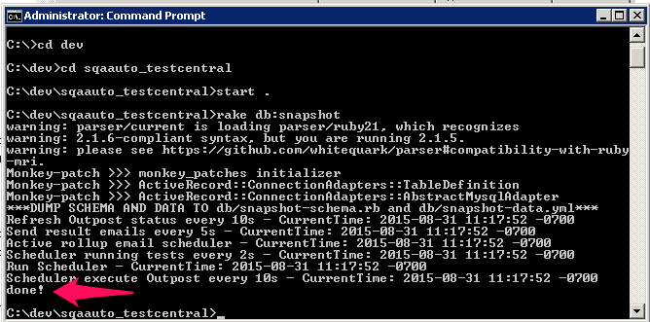

1. Open “As Administrator” Command prompt and do DB migrate

cd \dev\sqaauto_testcentral

rake db:migrate  
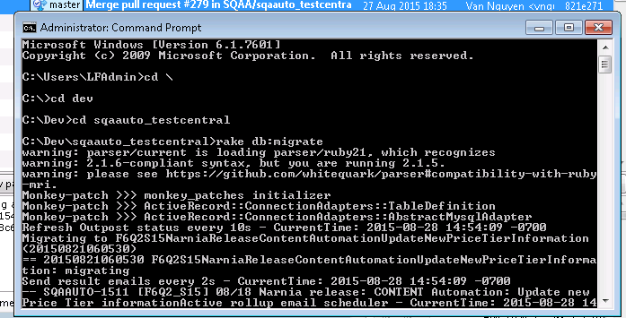

**3. Restart Server**

1. Close old server command prompt

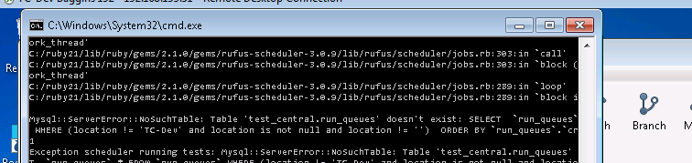

1. Run “As Administrator” the Run_TestCentral.bat file on the desktop

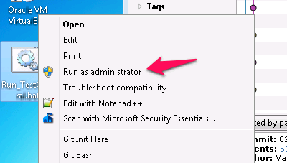

1. Expect address to be “https://0.0.0.0:443”  
   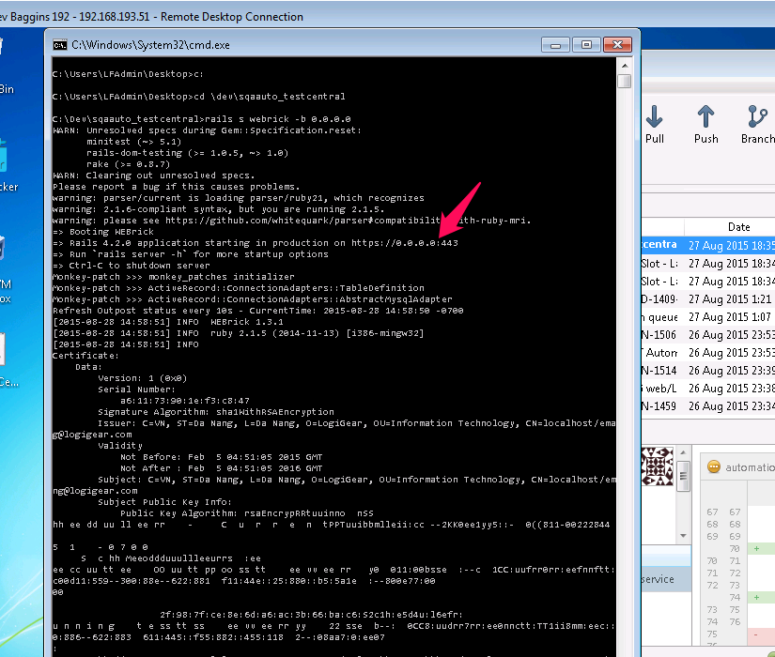
2. Expect to see “Signature Algorithm”  
   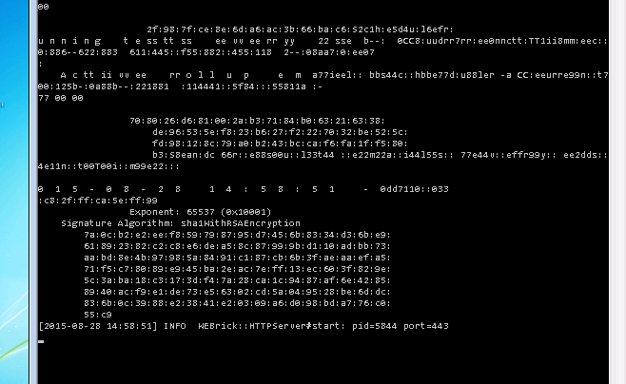
3. Test the website to make sure it works
4. Run a test and view the results and check the email

**4. Troubleshooting**

**Can’t pull from Stash**

This often is a problem with TC-QA1 (naemqasel02) where the branch doesn’t refresh.  
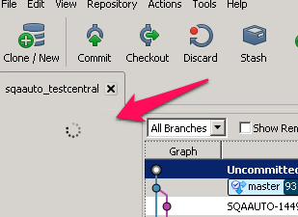

1. Closing Source Tree
2. Closing PAgent in the Taskbar notification area

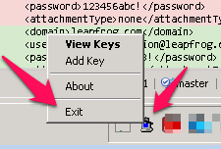

1. Killing the sh.exe process (it is the Git shell process that gets stuck

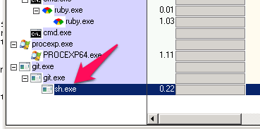

1. Try again?
2. Or try using Git Bash console

cd /c/dev/sqaauto_testcentral

git pull origin master

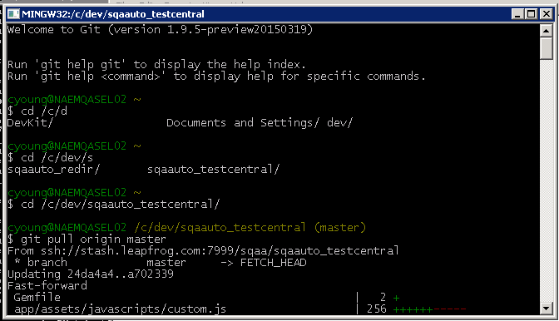

**Setup SSH key**

To setup an SSH key locally for Fetch/Pull requests, you need to add it via the Tools menu in SourceTree (this adds it to the Putty SSH Agent, which runs in the taskbar notification area and launches with SourceTree). This only needs to be done once.

